NEBRASKA STATE FIRE MARSHAL
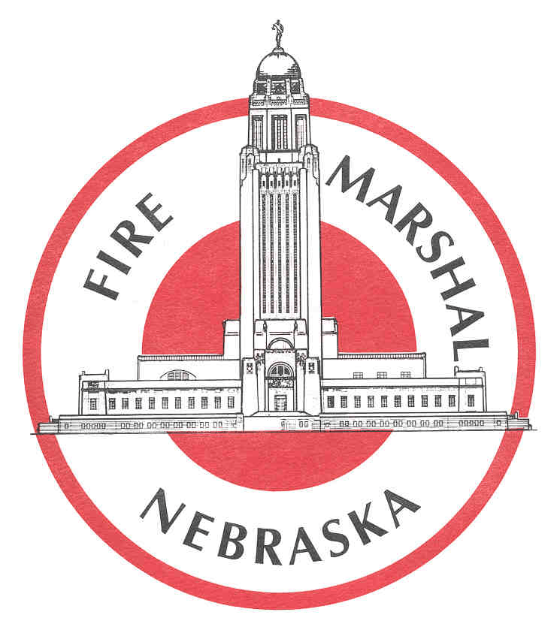
OFFICIAL INTERPRETATION

Interpretation Number: 07-03 |  | Comments:
Date: 09-07
Pamphlet Number: NFPA 101, 2000 ed.
Section(s): 24.1.1.1, A26.1.1.1
Question: How are Bed and Breakfast occupancies classified in the Life Safety Code?
Response:

Classification and fire code requirements for a home or structure used as a bed and breakfast occupancy are based on the maximum number of renters using the facility.

A bed and breakfast occupied by four or fewer renters of any age is classified as a one-and two-family dwelling.

A bed and breakfast occupied by more than four renters of any age is classified as a Lodging and Rooming House.

This arrangement will typically allow the use of up to two rooms of a bed and breakfast occupancy to be rented without triggering the more extensive requirements of a Lodging and Rooming House.

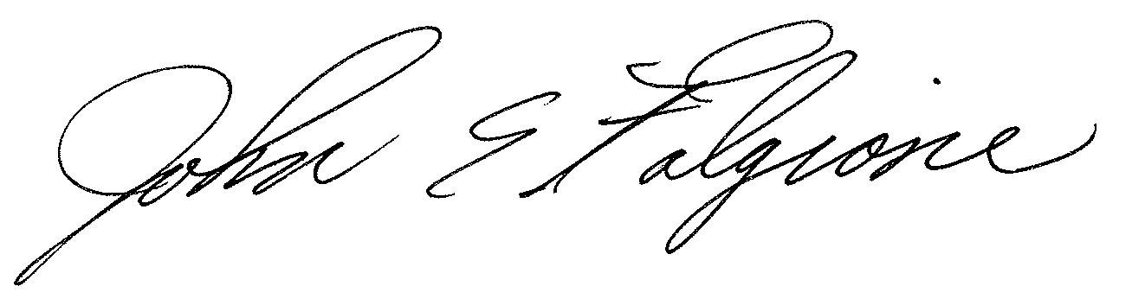  Signature: |  | Date: 09-12-007
Title: John E. Falgione, State of Nebraska Fire Marshal

